Decisions

Look at this code:
choice = input("Choose walk or read: ")
if choice == "walk":
print("Take a walk in the park.")
else:
print("Read a book at home.")

What do you think this code will do if the user enters 'walk'?
Click or tap here to enter text.

Run the code. Compare the result with your prediction:
Click or tap here to enter text.

Let’s investigate! Answer the questions below:
- Why does walk run the if block but Walk run the else block?
Click or tap here to enter text.

- What does the program display if the user types cycle, even though cycle is not one of the suggested choices?
Click or tap here to enter text.

- If you type read, what message appears and which block runs?
Click or tap here to enter text.

- Why can the if and else blocks not both run during the same decision?
Click or tap here to enter text.

Decisions

Look at this code:
choice = input("Choose walk or read: ")
if choice == "walk":
print("Take a walk in the park.")
else:
print("Read a book at home.")

Use the code above to help you. After completing each challenge below, run your program to test that it works correctly. Save each completed challenge program in a new file.

Programming Challenges

Challenge 1
Run the starter once with "walk" and once with "read". Then replace only the walk recommendation with a library message. Both inputs must still lead to different messages.
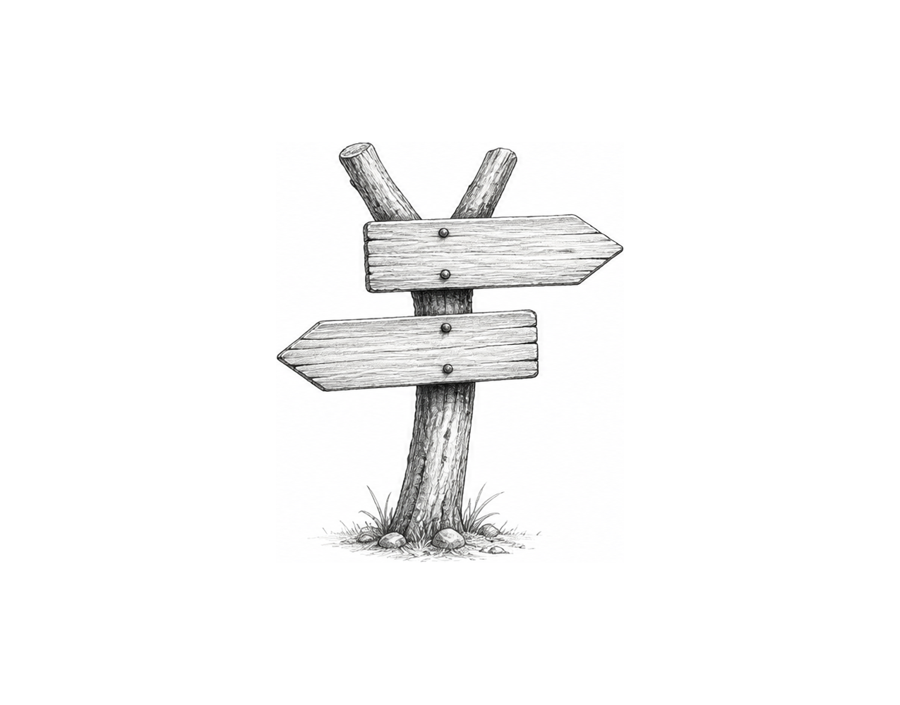

Challenge 2
Personalise both routes: ask for the user's name, then include it in whichever recommendation appears. Check that the name is shown for both possible choices.

Challenge 3
A cafe asks, "Do you want tea?" Use if and else to build a two-way choice: yes displays "Tea is ready."; every other answer displays "Choose another drink." Test one input for each route.

Decisions

Fix the code!

This code has errors! Look closely at the code to find the problems:

choice = input("Choose walk or read: ")
if choice == "walk":
print("Take a walk in the park.")
else:
print("Read a book at home.", display_choice)

Rewrite the whole program in the box below with fixes to the errors.
Click or tap here to enter text.

After you are confident that you fixed all the errors, copy the code from the box and run it.

Did it work correctly on your first try? Did you find all the errors?
Click or tap here to enter text.

